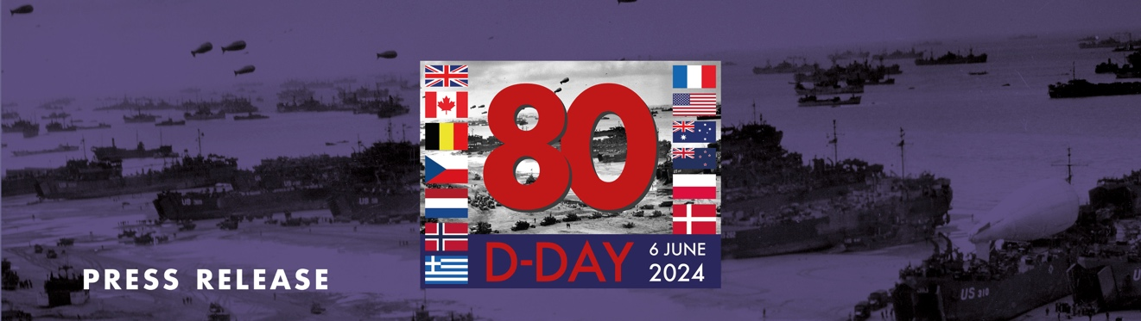

D-DAY80: HOW MIDDLEHAM WILL REMEMBER FALLEN HEROES

On Thursday, June 6 the nation will come together to remember the tens of thousands of allied forces who gave service on D-DAY eighty years ago and helped secure the peace we in the UK enjoy today.

From early morning when the sun rises to evening as night descends, church bells will ring out, special flags will be flown, schoolchildren will learn stories about their great grandparents, town criers will proclaim the victory, the haunting sound of bagpipes will fill the air and, in a final gesture of homage, beacons and Lamp Lights of Peace will be lit to signify the light that emerged from the dreadful darkness of war.

Councillor Honor Byford, Mayor of Middleham, will be joining hundreds of others wanting to remember the brave men and women who took part, not only from our country, but from America, Canada, Australia, New Zealand, Belgium, Norway, Greece, France, Czechoslovakia, Rhodesia, and Poland too. The beacon will be lit at 9.15pm on Thursday 6th June 2024 at Middleham Castle for any residents who wish to attend.

Cllr Byford, says, “To be able to play even a small part in paying tribute is humbling and a great honour. As an Army Veteran myself, I can well imagine how those who embarked on such a major operation into the teeth of a well defended enemy army must have felt. It was a daunting undertaking in which every individual must have wondered if they would survive the day, and many did not return. For those who survived and who then fought on through Europe all the way to Berlin, and who liberated the Nazi Death Camps, many were changed for ever, whether physically, mentally, or both. So many soldiers and their families lived and are living with the effects of war for the remaining decades of their lives. Our freedom is bought in blood and treasure, then and now.”

“In Middleham, we have raised our bunting and festive lights to commemorate those from this community and beyond who served in the D Day Operations. At 9.15pm we will light a beacon at the top of the ancient Keep of Middleham Castle, where soldiers have stood guard over many centuries and whose spirit and memory we honour again on this momentous anniversary. May the Peace they fought for be preserved and maintained now and for our children’s children.”

Bruno Peek CVO OBE OPR Pageantmaster of D-Day80, and of the 80-day countdown to June 6, 2024, says; “In 1944 Allied forces mounted the largest amphibious invasion the world has ever witnessed. Operation Overlord, D-Day, saw over 5,000 ships and landing craft set down more than 150,000 troops on the five Normandy beaches that would bring about the liberation of north-west Europe from Nazi occupation.

“In order to commemorate the peace and freedom given to us through the bravery and ultimate sacrifice of so many thousands involved in the D-Day landings, and throughout the whole of WW11, beacons and Lamp Lights of Peace will be lit across the United Kingdom, Channel Islands, Isle of Man and UK Overseas Territories - and in a very poignant and unique gesture, a special Lamp Light of Peace lamps will be lit on each of the five beaches in Normandy, at 9.15pm local time that night, to coincide with the lighting of beacons at that time too.

“However, at 9.10pm, as night descends - and just before the beacons ignite - the resonant sound of bagpipes will be heard across the capital cities of London, Edinburgh, Belfast, and Cardiff. We will also have a presence in the capital cities of the Allied nations that took part. From Washington DC to the distant shores of New Zealand’s Auckland, from Ottawa to Paris, and from Canberra to Brussels, Athens and Amsterdam, Oslo, Warsaw, and Prague.
“The light from the flames from the lamps and the beacons will represent the ‘light of peace’ that emerged from the darkness of war, with the lamp providing a very simple, safe, unique and cost effective way of taking part in this important 80th anniversary occasion, especially as once used, can be lit again at 11am on every Remembrance Sunday thereafter, in tribute to the many millions that sacrificed their lives during WWII.”
